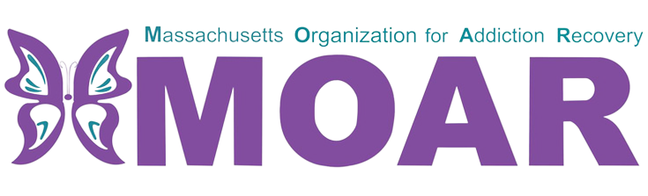

Northeast Opioids Fact Sheet
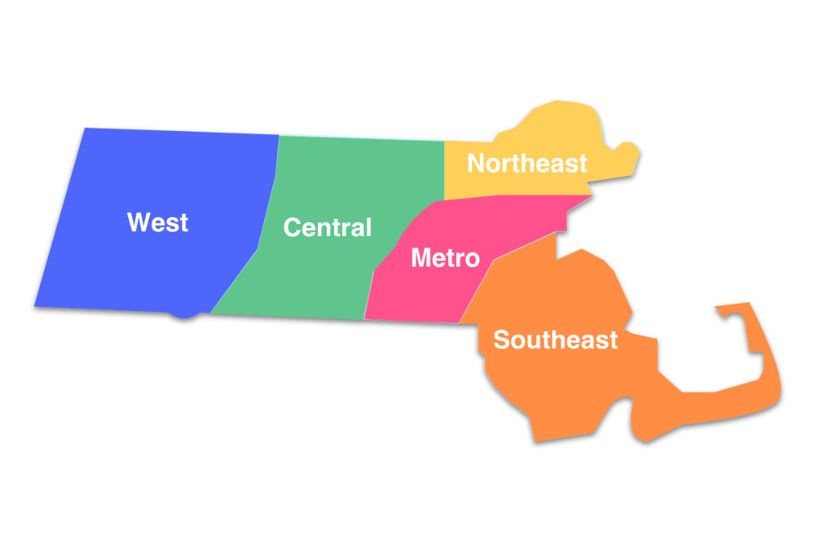

What are opioids?

In 2021, the total number of confirmed opioid-related overdose deaths per county were 289 in Essex.
Opioids are a type of drug that is prescribed to reduce pain. The frequent use of opioids can lead to developing tolerance and dependence.

City/Town  across  Northeast MA | Total opioid-related overdose deaths (2020) | Total opioid-related overdose deaths (2021)
Lynn | 49 | 61
Gloucester | 12 | 17
Haverhill | 31 | 33
Andover | 0 | 8
Methuen | 14 | 11
Saugus | 14 | 11
Beverly | 14 | 8
Rockport | 4 | 0
Lawrence | 55 | 39
Between 2020 and 2021:
- Lynn, Gloucester, Haverhill, and Andover had an increase in opioid-related overdose deaths.
- Methuen, Saugus, Beverly, Rockport, and Lawrence had a decrease in opioid-related overdose deaths.

What is the current situation in Essex County?

In 2021, the total number of confirmed opioid-related deaths was 289. There were 36 more deaths reported compared to the previous year.
This fact sheet provides the most recent data on opioid statistics published by Massachusetts Department of Public Health. For more information, please visit the website at
https://www.mass.gov/lists/current-opioid-statistics

